|  |
| --- |
| EPAM Systems, RD Dep. |
| MTN.BI.08 Transportation |

|  |  |  |  |  |  |
| --- | --- | --- | --- | --- | --- |
| REVISION HISTORY | | | | | |
| Ver. | Description of Change | Author | Date | Approved | |
| Name | Effective Date |
| 1.0 | Initial status | [Hanna](mailto:Kiryl_Bucha@epam.com) Hul | 12-JAN-2012 |  |  |

Contents

1. ETL Transportation - Analytical 3

1.1. Transportation Description 3

2. ETL Extraction – Example of Loading FCT_* 3

2.1. Prepare Table of Facts to SAL Layer 3

3. Transportable Tablespaces and DBLinks 3

4. Hierarchies 3

# Transportable Tablespaces and DB Links

Create sample usage of transportable tablespaces and database links and describe it in document with screenshots and description.

User was created and given special grants. But all tryings to create db link failed.

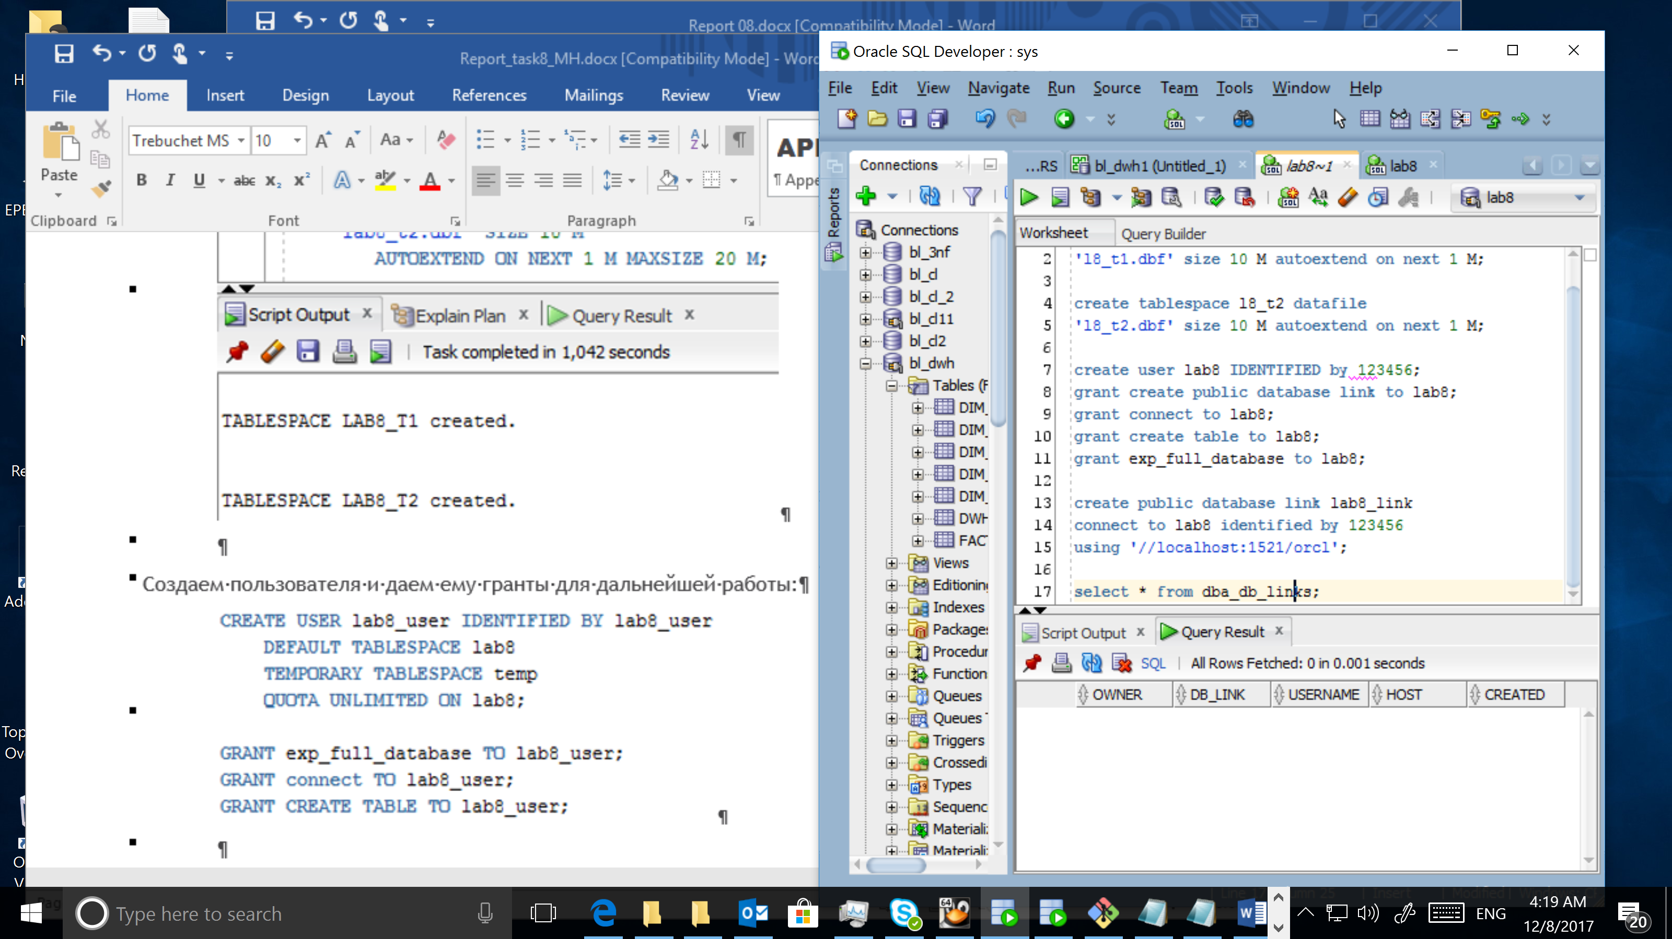

# Table Functions

Replace at least one cleansing (CLS) table with Oracle Table function.

